|  |
| --- |
| EPAM Systems, RD Dep. |
| MTN.BI.08 Advanced Refresh Scenarios |

|  |  |  |  |  |  |
| --- | --- | --- | --- | --- | --- |
| REVISION HISTORY | | | | | |
| Ver. | Description of Change | Author | Date | Approved | |
| Name | Effective Date |
| 1.0 | Initial status | [Hanna](mailto:Kiryl_Bucha@epam.com) Hul | 12-JAN-2012 |  |  |

Contents

1. Business Task – Performance of STAR Scheme 3

1.1. Prepare Report Layout 3

1.2. Compare Report Layout Performance 3

2. Advanced Loading 3

3. ETL Structure 3

# Business Task – Performance of STAR Scheme

## Prepare Report Layout

The Main Task is to create SQL for Report Layout that was developed in the concepts of your business in the last module (Use STAR schema objects for source of Data).

## Compare Report Layout Performance

The Main Task is to create summarize table with comparison Performance of next Report Layout:

* 3NF (Staging)

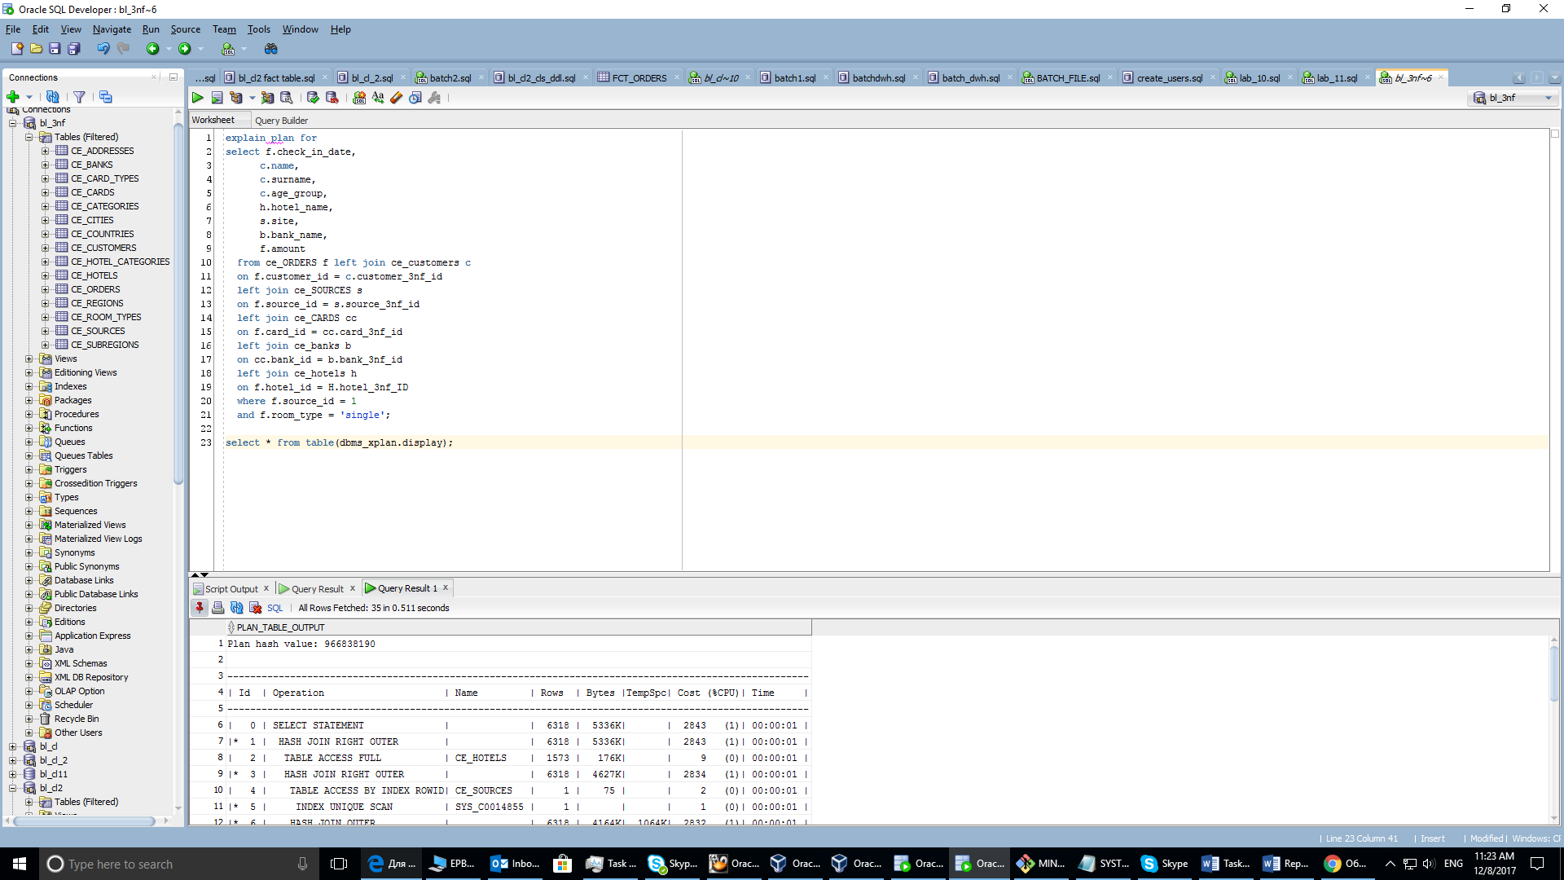

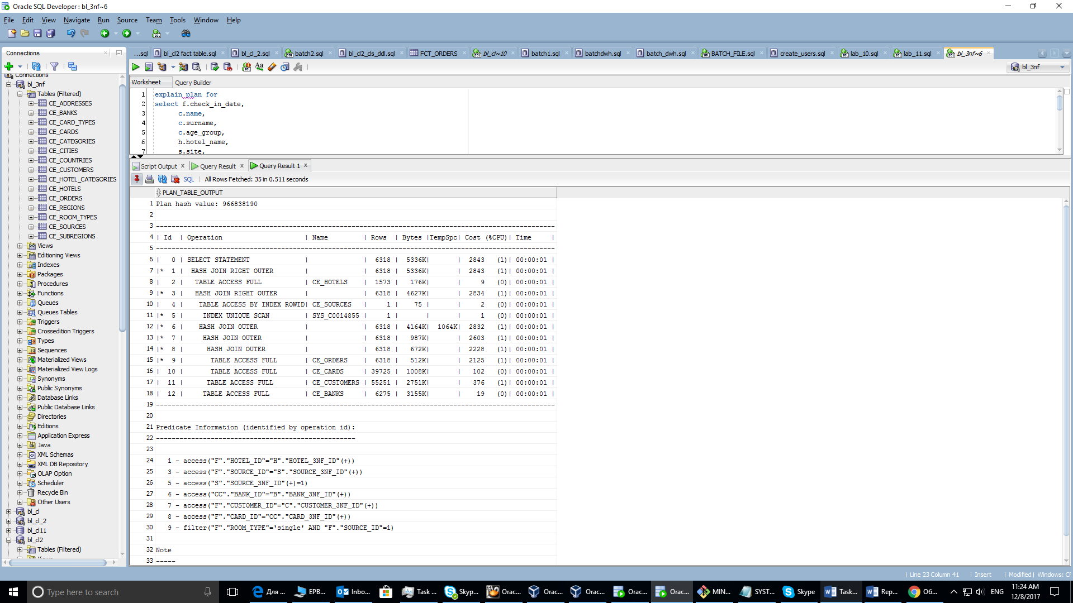

***Time: 0.511 seconds***

* Star Schema (Lab Work 11)

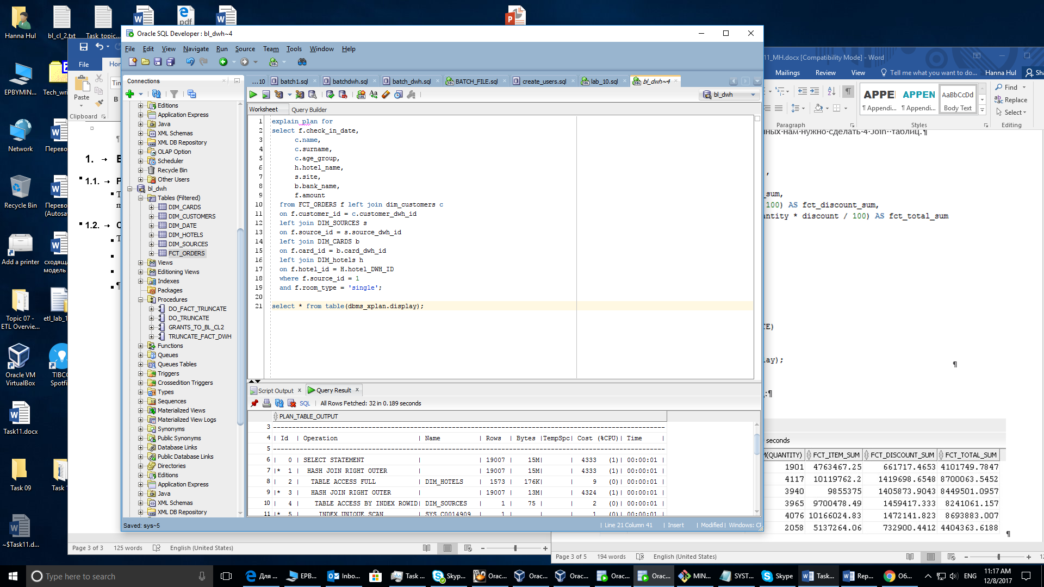

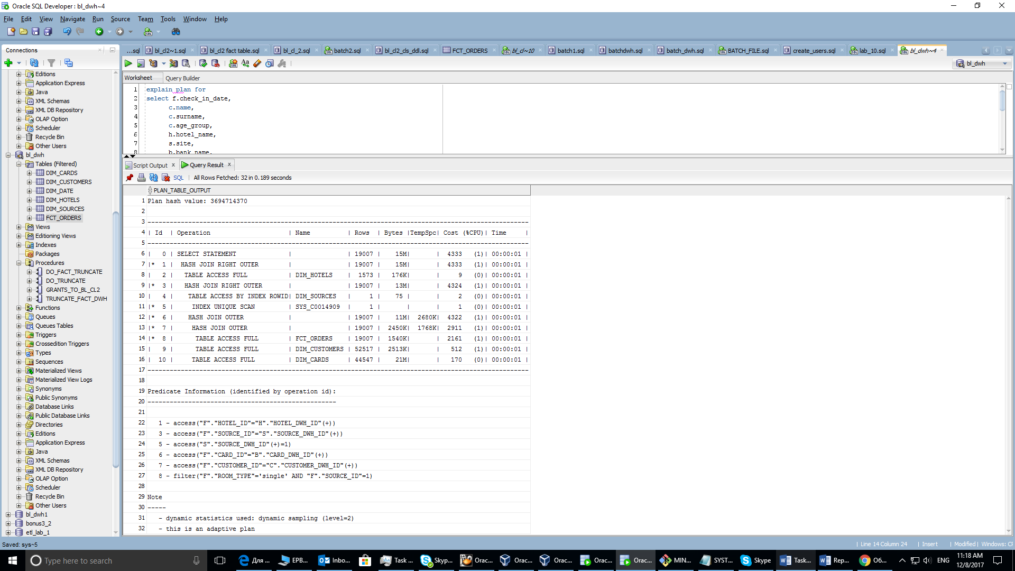

***Time: 0,189 seconds***

The speed of loading data is much higher in star schema. It is obvious connected with the concept of star schema (dimensions contain all needed data). So the result shows, that main goal of dwh – “win” time of performance was achived.